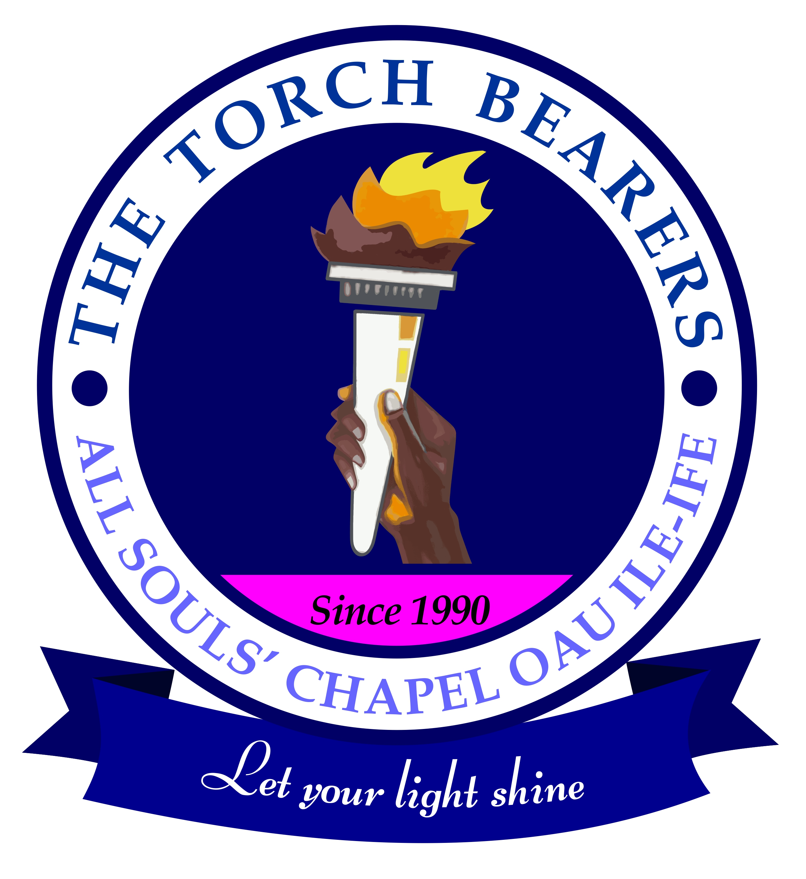
THE TORCH BEARERS
ALL SOULS’ CHAPEL, OAU, ILE-IFE
MOTTO: Let your light shine
The Torch Bearers is a Fellowship in All Souls’ Chapel, OAU,Ile-Ife.
Thanks for indicating interest in joining the Fellowship. In order to know you better, kindly fill and submit this form to the Secretary of The Torch Bearers.

- Name…………………………………………………………
- Phone No:……………………………………………………
- Occupation………………………………………………….
- Status………………………………………………………..
- email Address……………………………………………….
- Contact Address…………………………………………… .
- Home Address……………………………………………….
- Marital Status……………………………………………….
- Occupation…………………………………………………..
- Denomination……………………………………………….
- Date of Birth…………………………………………………
- Have you been baptized: a. Yes b. No
- Why are you interested in the Fellowship?………………… ………………………………………………………………...
………………………………………………………………… .
……………………………………………………………….......
- Signature and date....................................................................
- Name of a Sponsor and Signature (must be a member of the Fellowship) …………………………………………………

