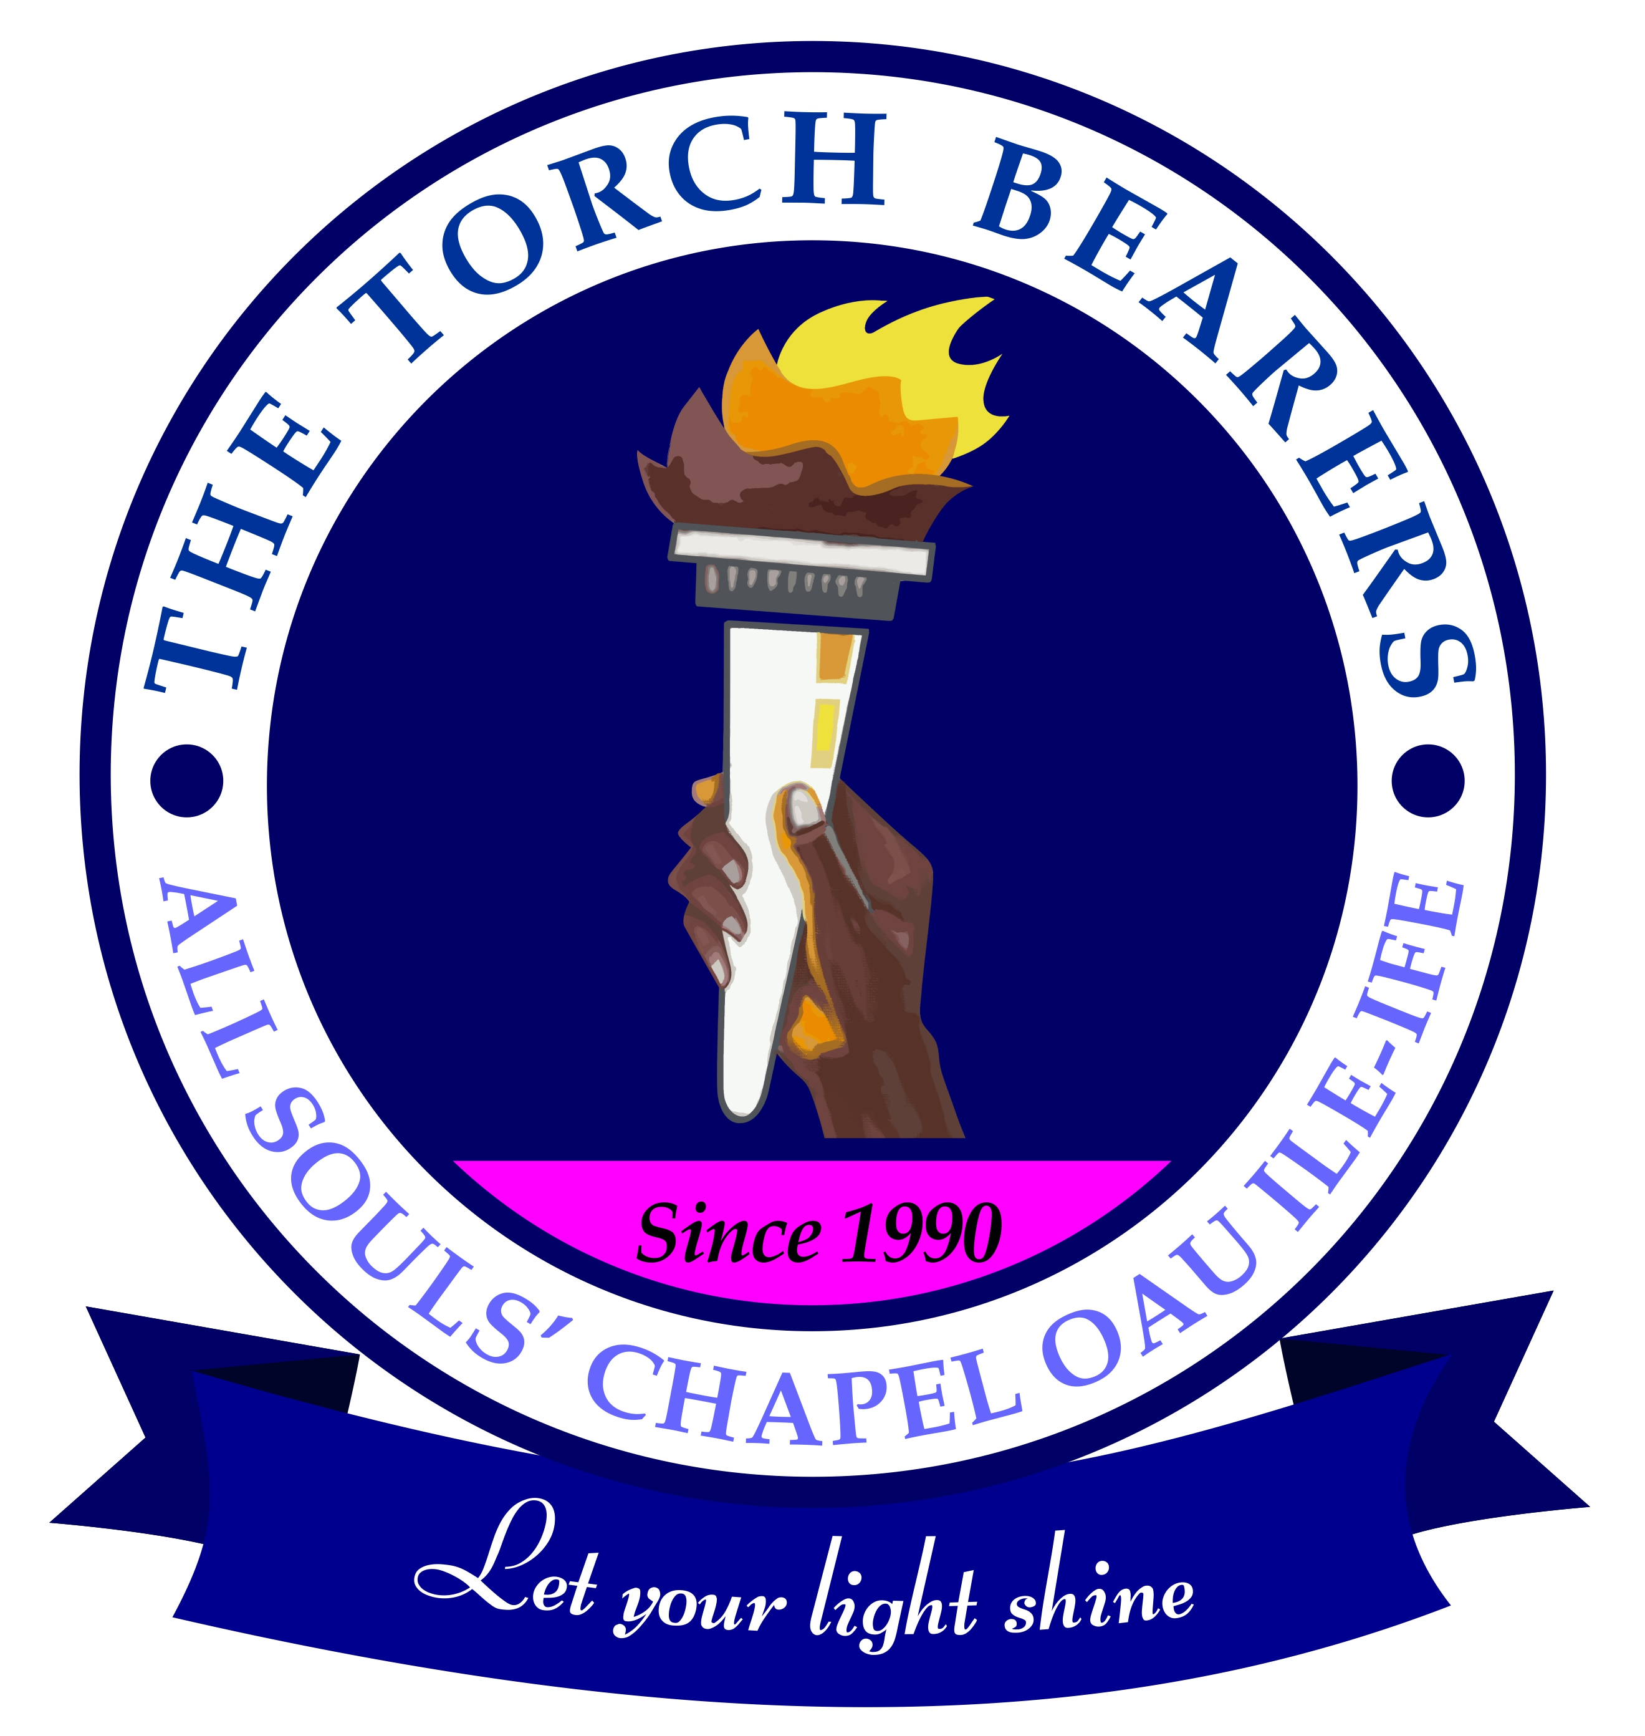

Paste
Passport
Photograph
THE TORCH BEARERS
ALL SOULS’ CHAPEL, O. A. U., ILE-IFE

THE TORCH BEARERS’ PRIZE IN BIBLE KNOWLEDGE 2022

Eligibility: Senior Secondary School Students

APPLICATION FORM FOR ONLINE SCREENING EXAMINATION
Instruction
Fill the form below as applicable and submit the e-copy on or before Monday 25thApril, 2022 to: thetorchbearersasc@gmail.com

Online Screening Examination: Saturday 7th May 2022 at 10.00 am
Written Elimination Examination on Saturday 14th May 2022 at All Souls Chapel, OAU, Ile-Ife, at 10.00 am

- Name (Surname first): …………………………………………………………….
- Date of Birth:………………………………………………………………...
- Gender: a. Male b. Female
- Class: a. SSS1 b. SSS2 c. SSS3
- Course Option: a. Science b. Arts c. Commercial d. Others
- Contact Phone No:………………………WhatsApp No……………………
- Contact e-mail address:………………………………………………………
- Home Address:……………………………………………………………….
- State of Origin:……………………………………………………………….
- Name of School………………………………………………………………
- School Address………………………………………………………………
- Name of Church……………………………………………………………...
- Denomination: ……………………………………………………………….
- Pastor’s Name and Phone No: ………………………………………………
15. List one referee (apart from the pastor stated above)
a. Name of Referee …………………………………………………………
b. Relationship………………………c. Phone No…………………………

16. How did you get information about ‘The Torch Bearers Prize in Bible
Knowledge’; a. Church b. Handbill/Poster c. Friends
d. Pastor e. Social Media f. Others (Please state)………………………

